What is Xray
- A test management tool fully integrated with Jira
- Used to manage manual and automated testing inside Jira
Why Xray is Used
- End-to-end test management without leaving Jira
- Traceability from requirements → tests → defects
- Supports Agile, Scrum, Kanban

XRAY installation
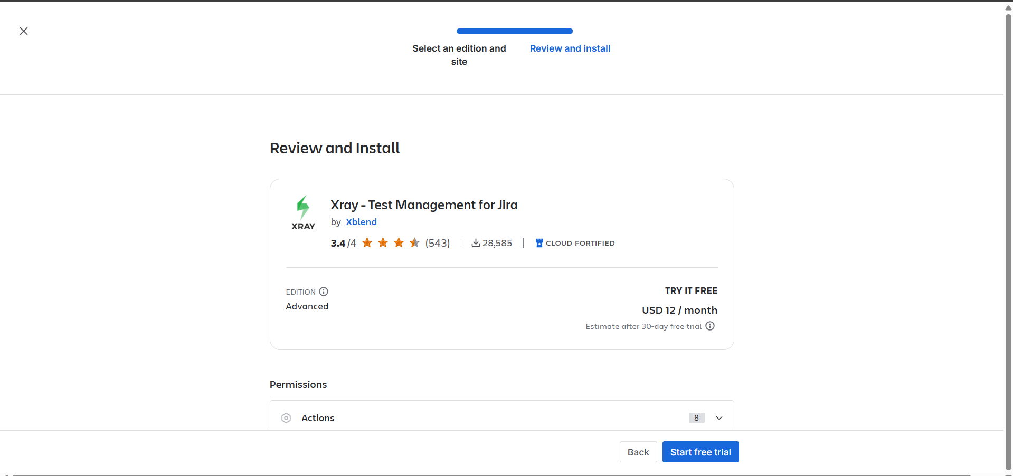

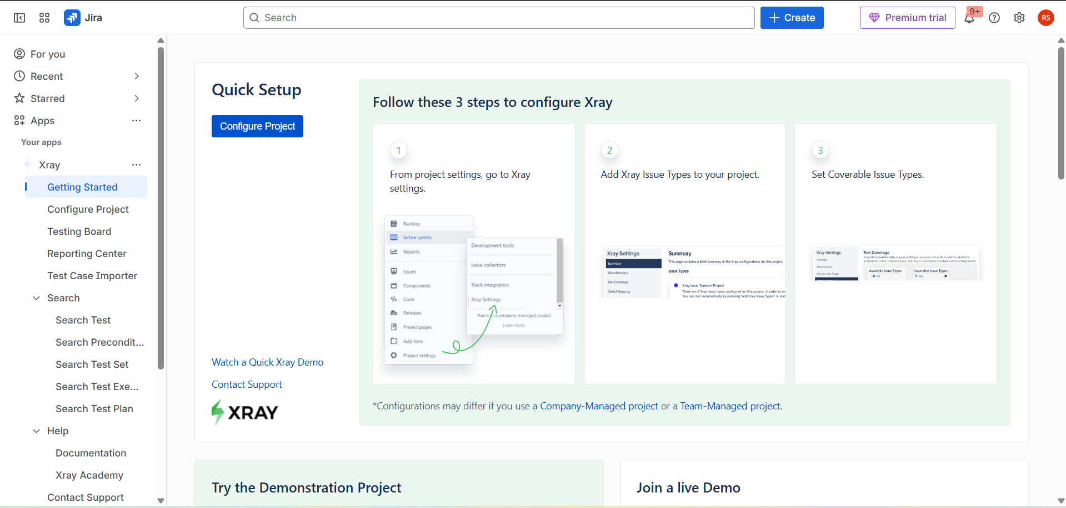
Project configuration in XRAY
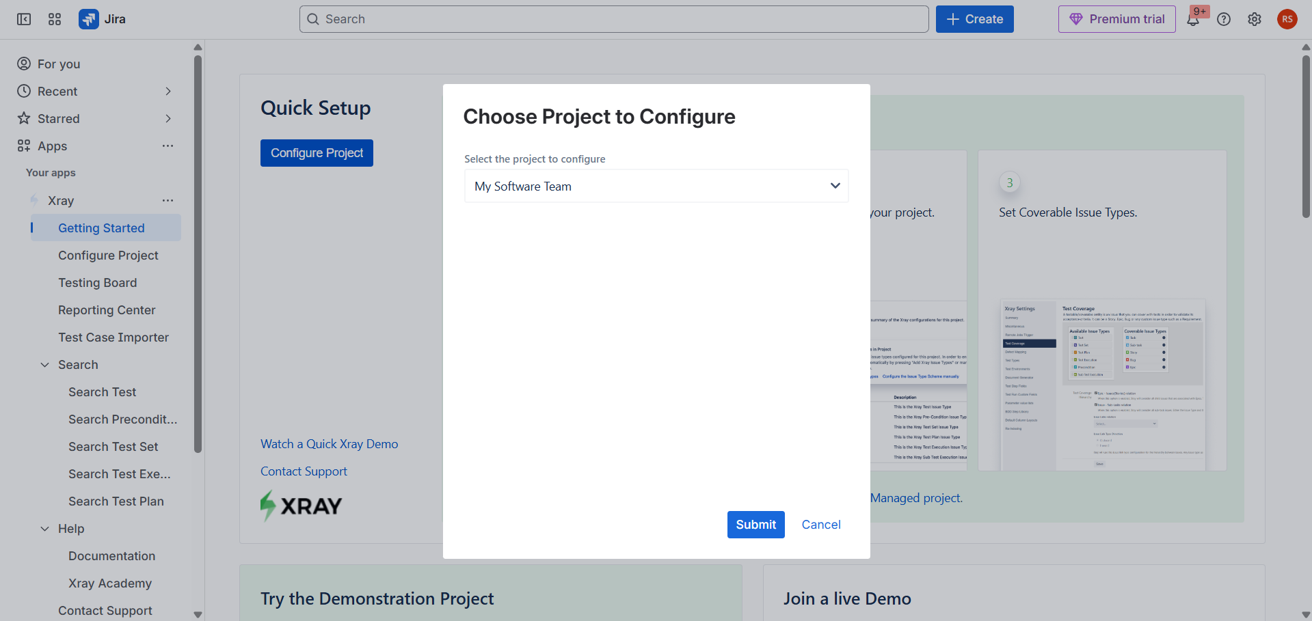
Enabling settings and configurations
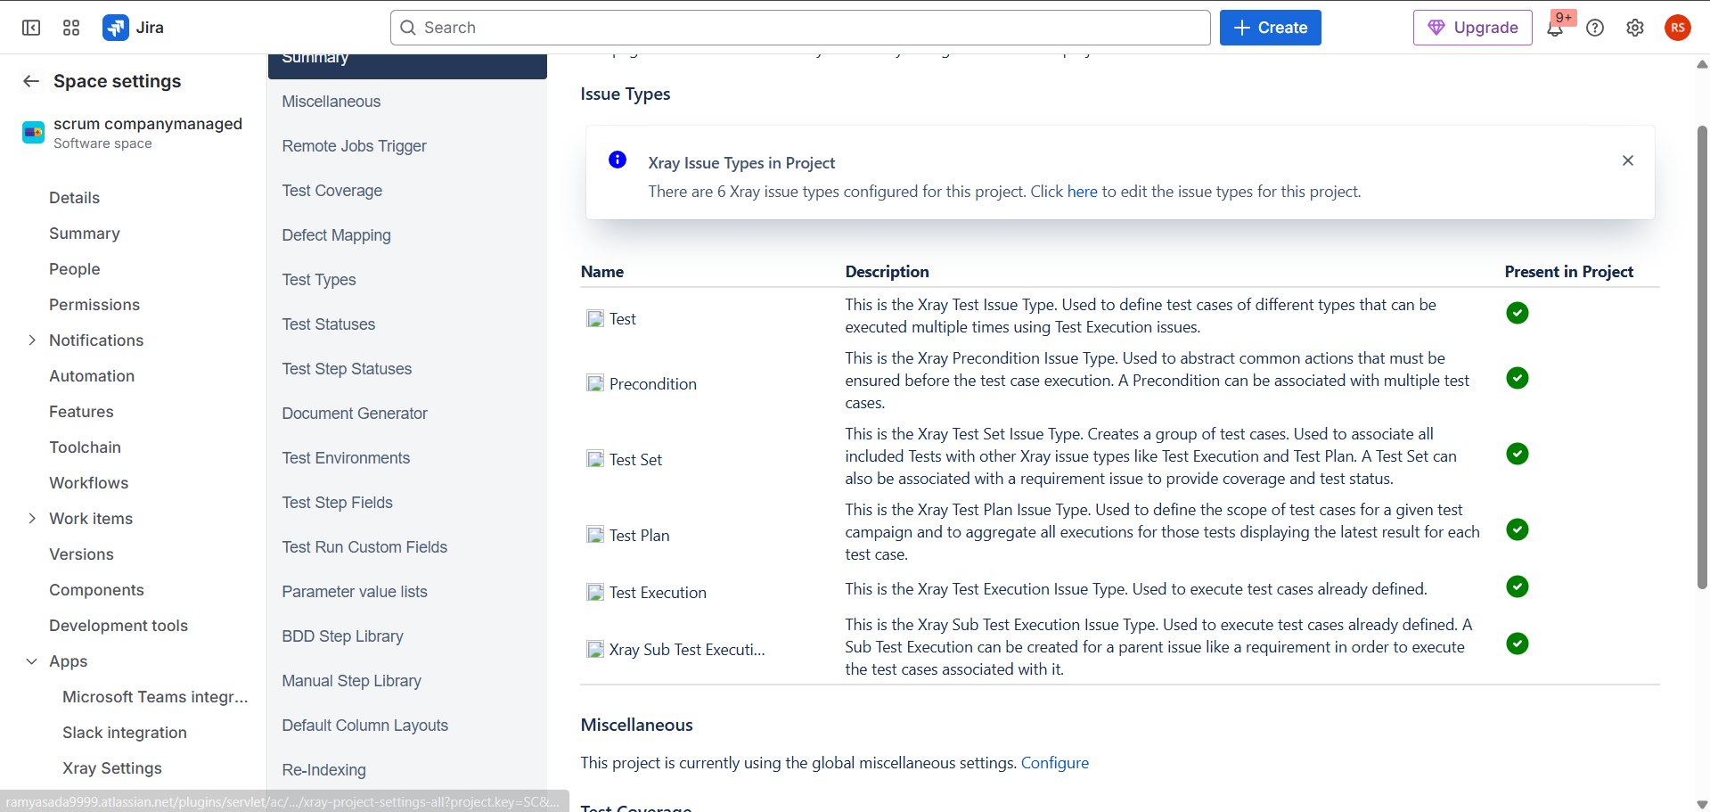
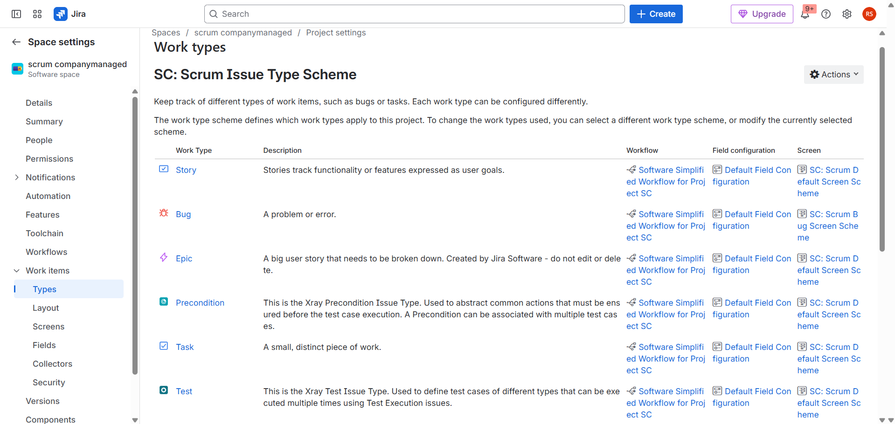

XRAY testing board
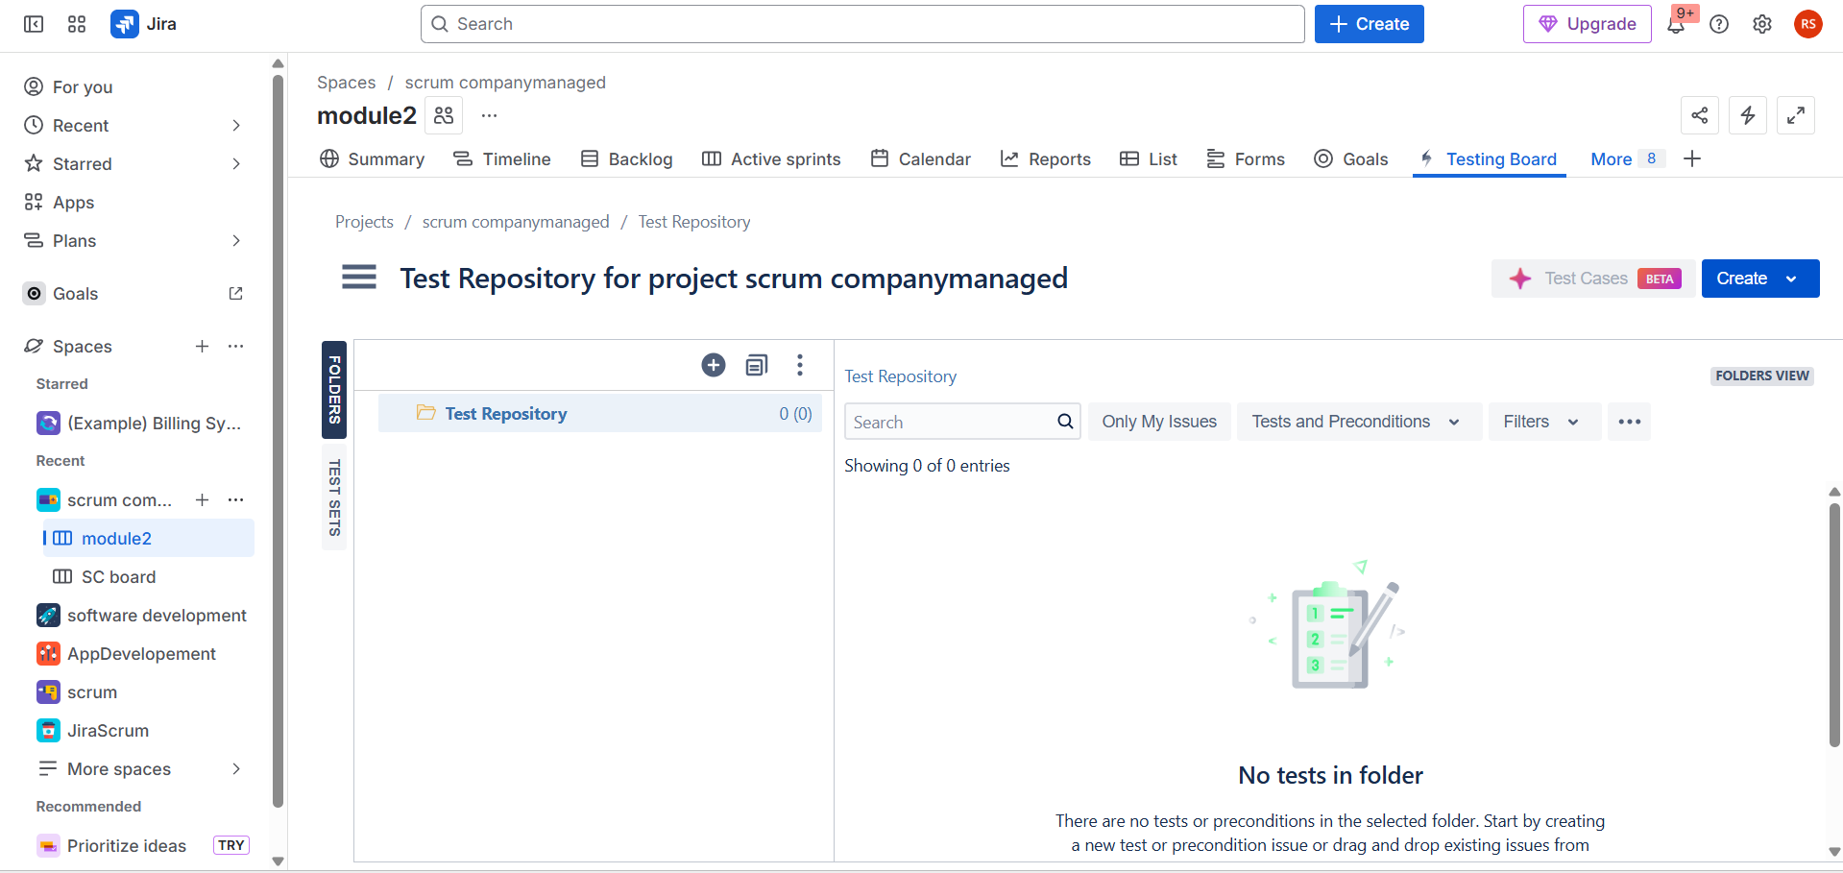
Key Xray Issue Types
- Test – Single test case
- Test Execution – Execution of tests with results (Pass/Fail)
- Test Plan – Organizes tests and executions
- Test Set – Groups related tests
- Precondition – Prerequisites for tests
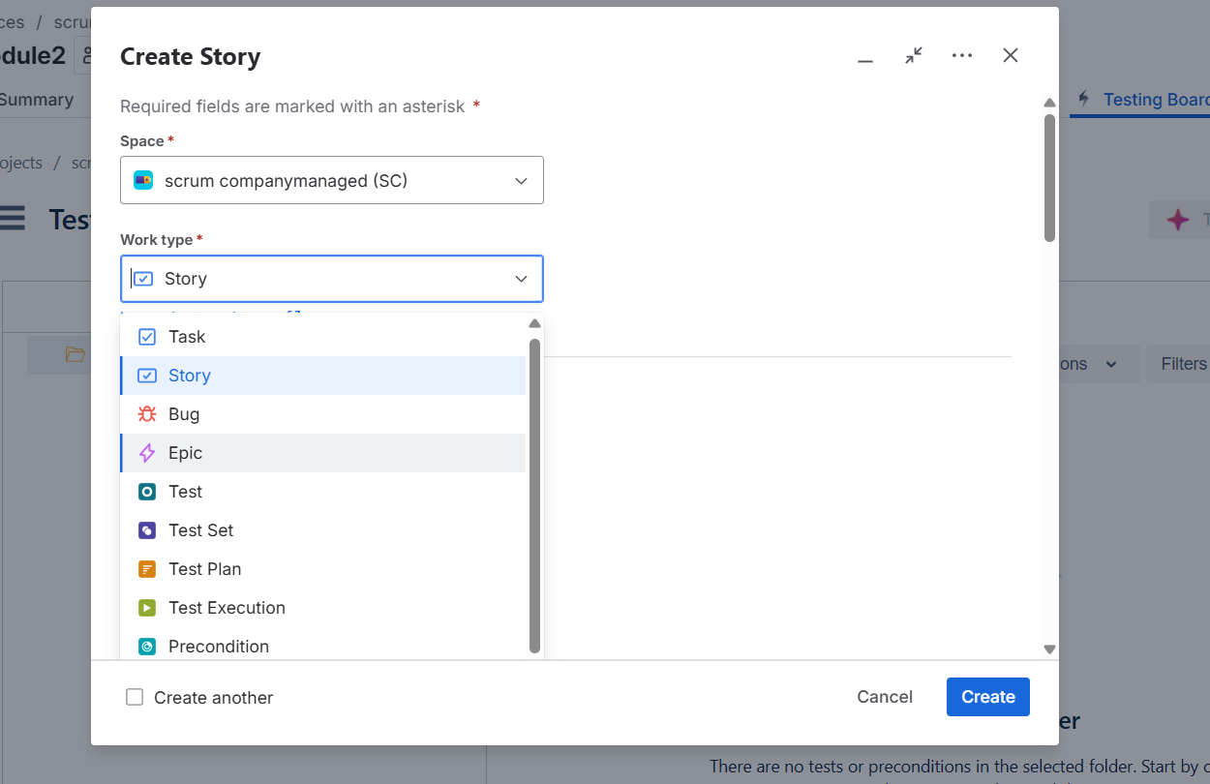
Test Management Features
- Create and manage test cases in Jira
- Link tests to Stories, Tasks, Bugs
- Manual test execution with evidence (screenshots, logs)
- Track test status and progress
Automation Support
- Supports JUnit, TestNG, Cucumber, Selenium, etc.
- Import test results via CI/CD pipelines
- View automated results directly in Jira
Creating a test in xray
Steps to Create a Test in Xray (Jira Cloud – Company-Managed Project)
- Open Your Jira Project
  - Go to Jira → Projects
  - Select a Company-Managed project (Xray works best here)
- Create a New Issue
  - Click Create (top navigation bar)
- Select Issue Type
  - In Issue Type, choose Test (Xray Test)
  - If “Test” is not visible, ensure Xray is properly installed and enabled
- Fill Basic Test Details
  - Summary: Test case title
    - Example: Verify login with valid credentials
  - Description (optional): Purpose of the test
- Add Test Type
  - Set Test Type:
    - Manual – for step-by-step execution
    - Cucumber – Gherkin syntax
    - Generic – external/automation tools
- Add Test Steps (for Manual Test)
  - Scroll to Test Steps
  - Click Add Step
    - Action: What the user does
    - Data: Input values (optional)
    - Expected Result: Expected outcome
  - Repeat for all steps
- Link Test to Requirement
  - In Linked Issues
  - Link the Test to a Story / Task / Bug
  - This ensures requirement traceability
- Save the Test
  - Click Create or Save
  - Your Xray Test is now created 🎉
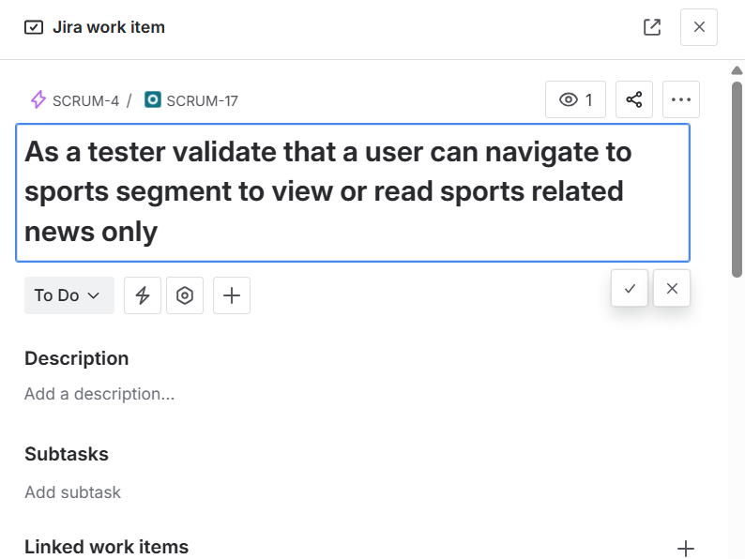

Test created

We can see in the following image for the test we have linked the work items as it seems that at the time of completing that linked work items that work items should be tested as mentioned
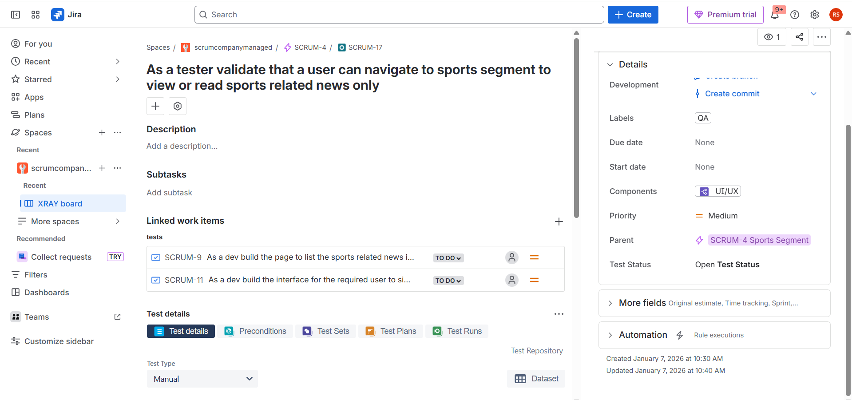
Add Test Steps

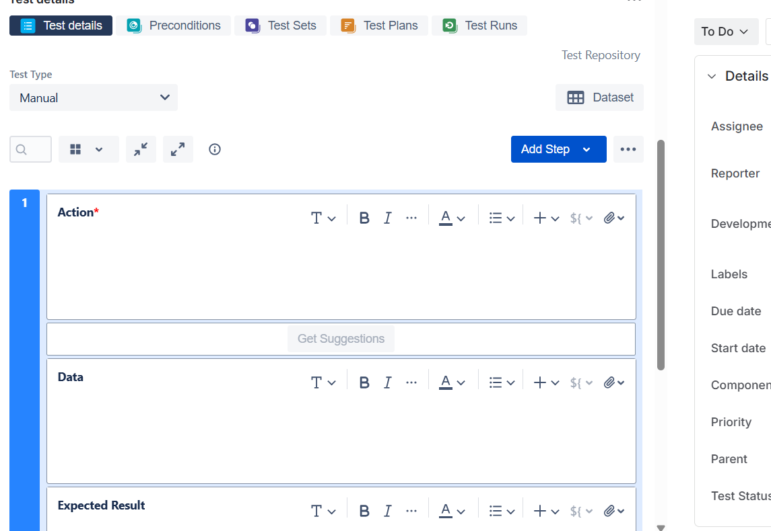

Test created
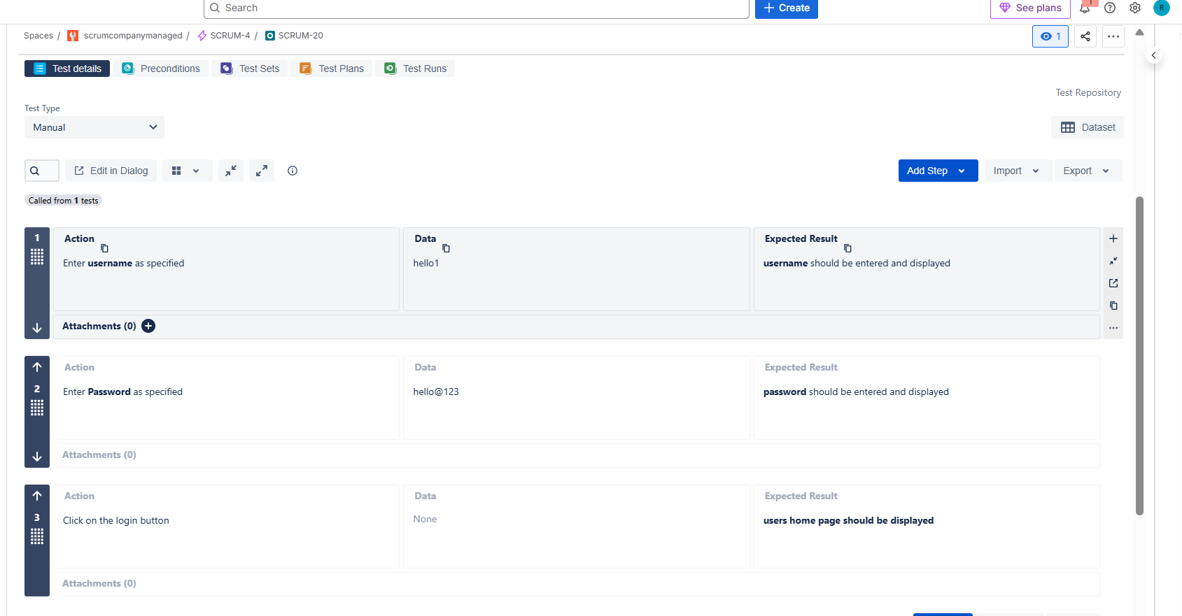
Calling a test of other module to the present module for the reusability
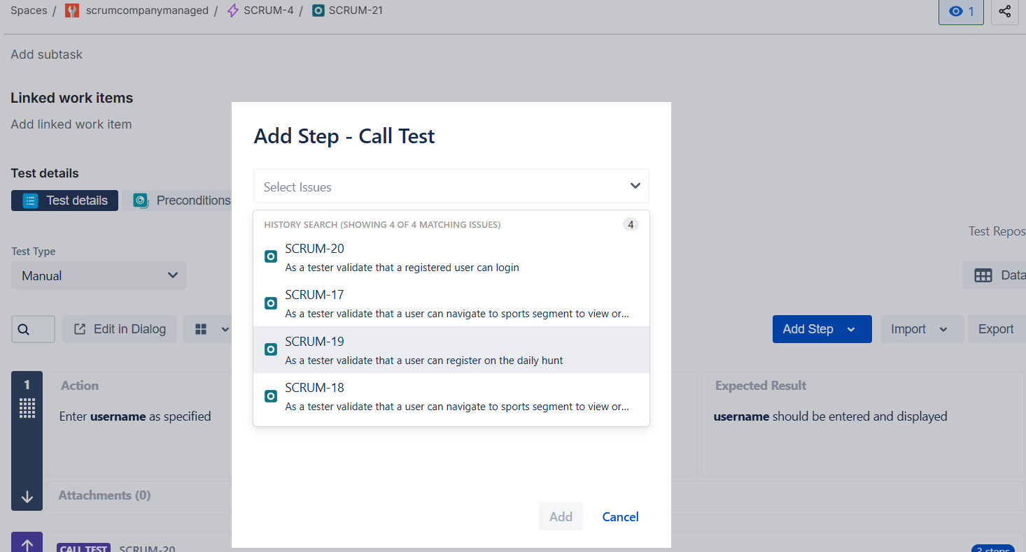
Entire Test step was called
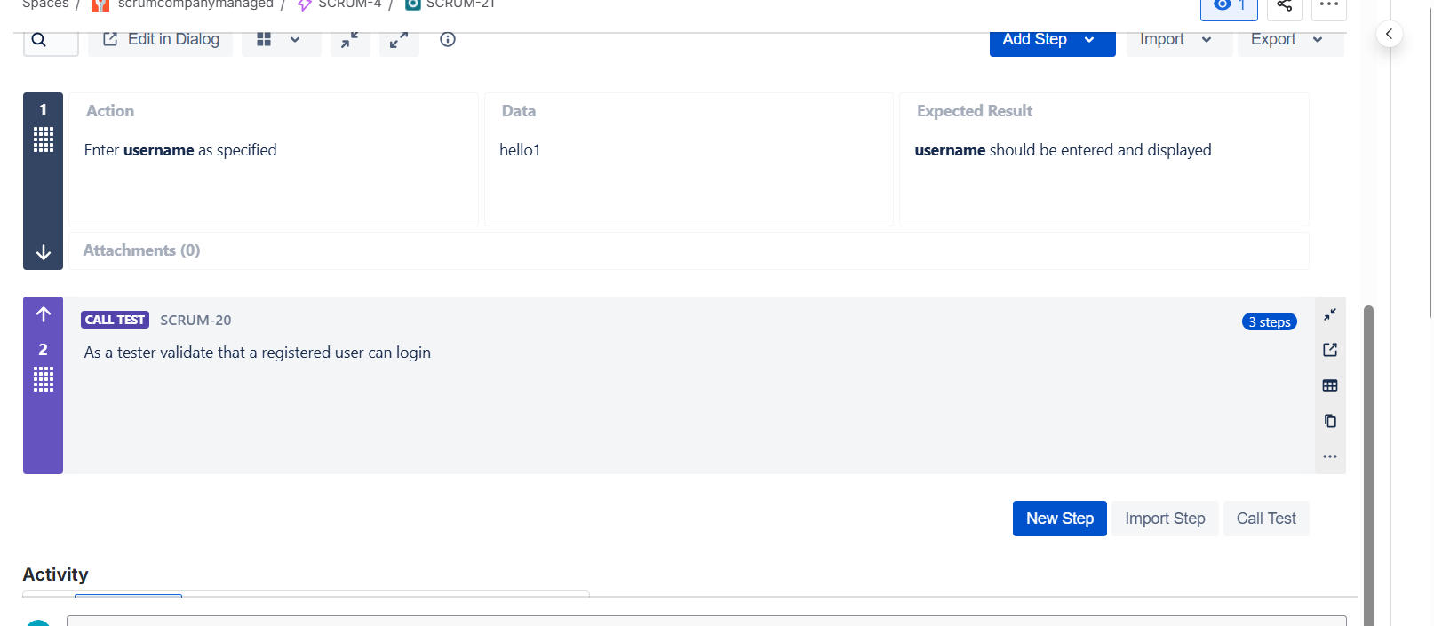
Only required test step was imported
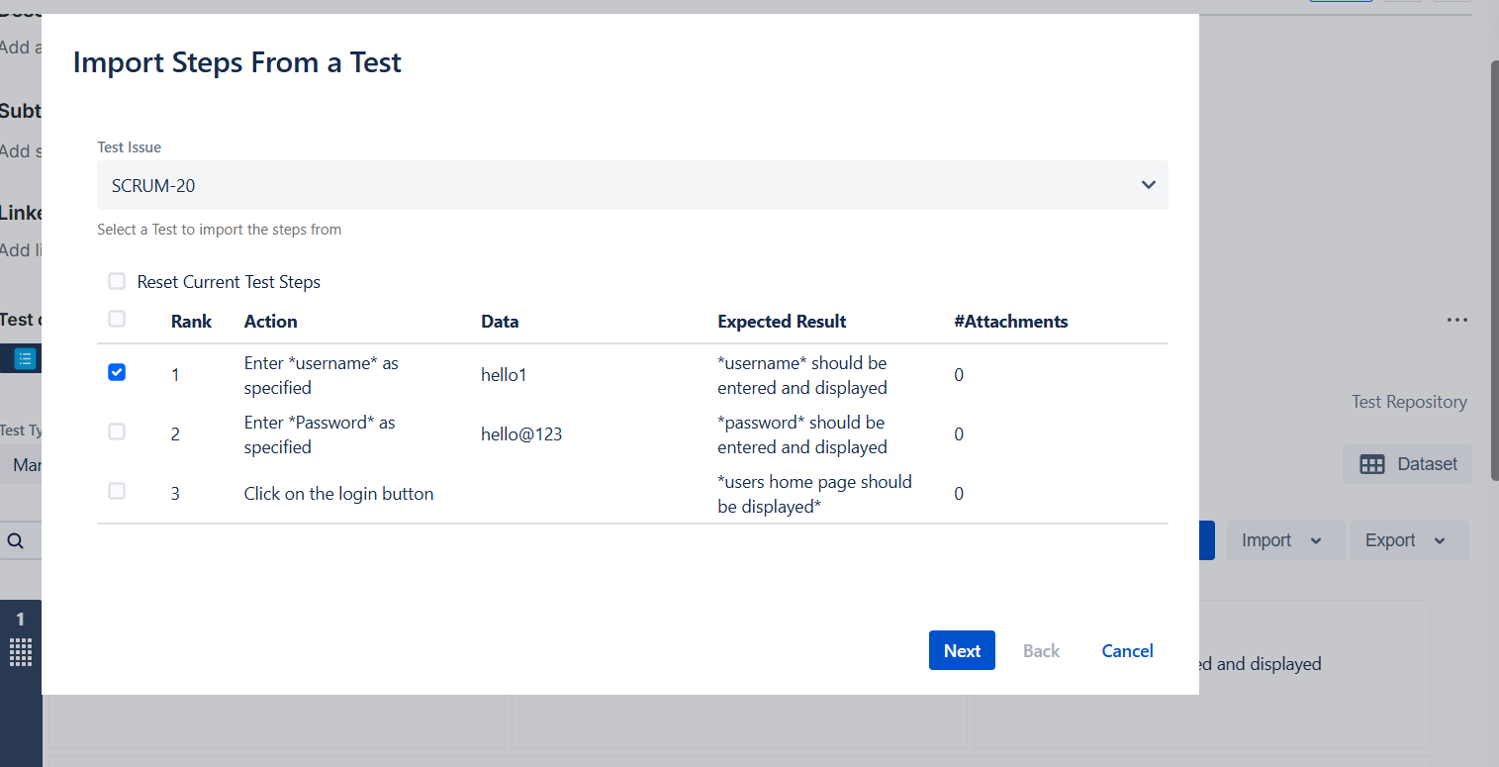
We can also drag the test steps when we want to complete the which step first
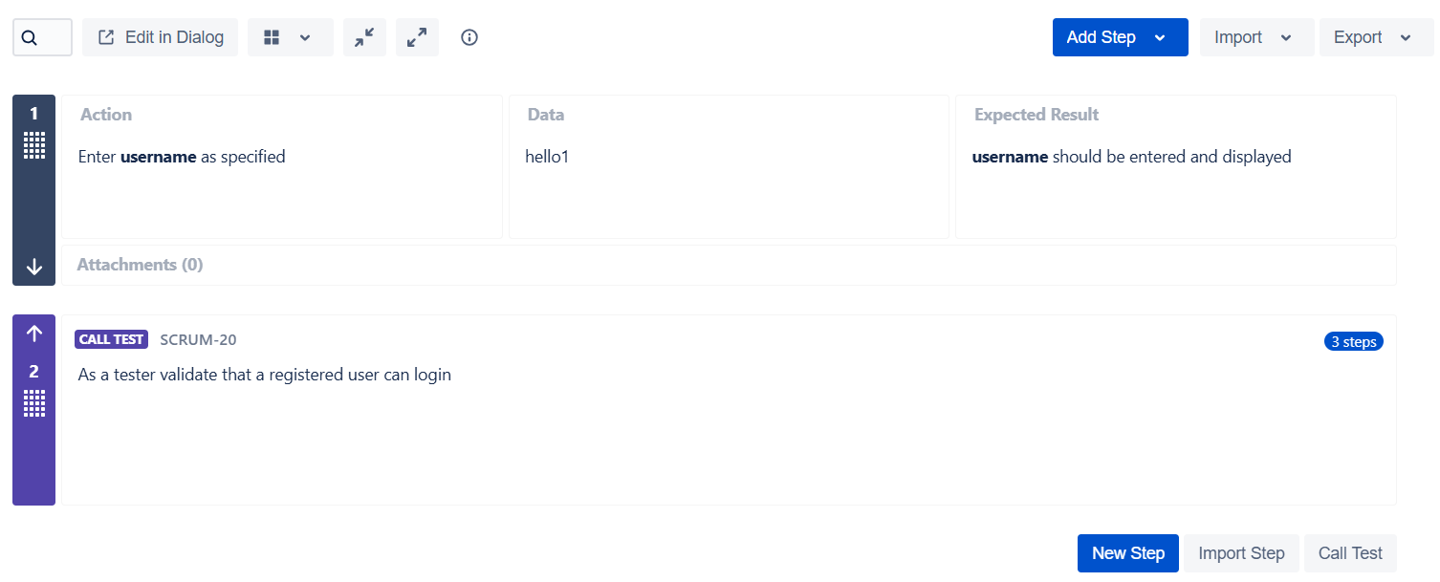
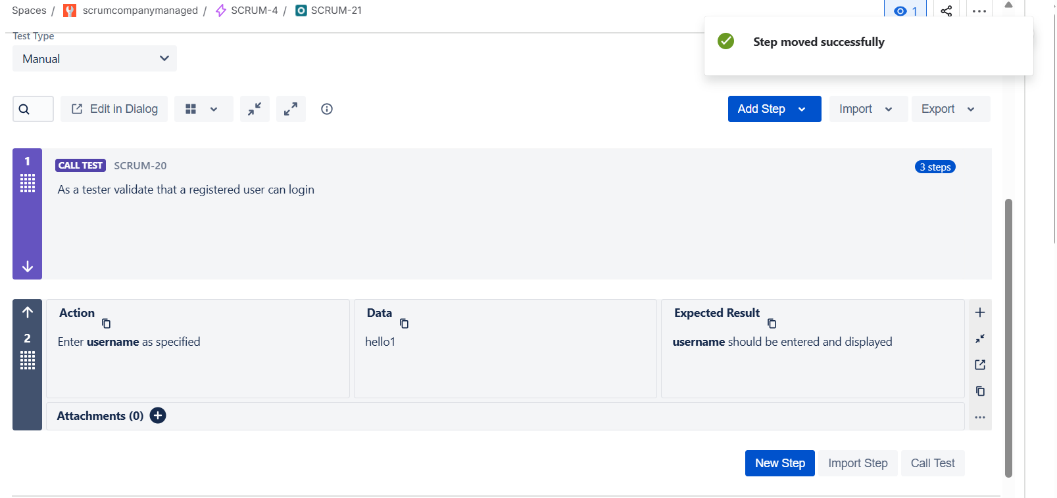
Creating a precondition
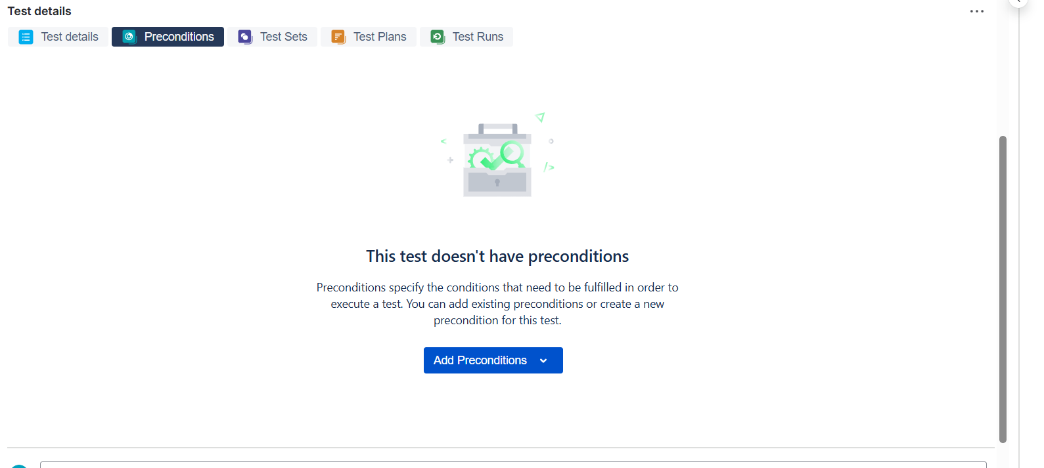

Precondition created
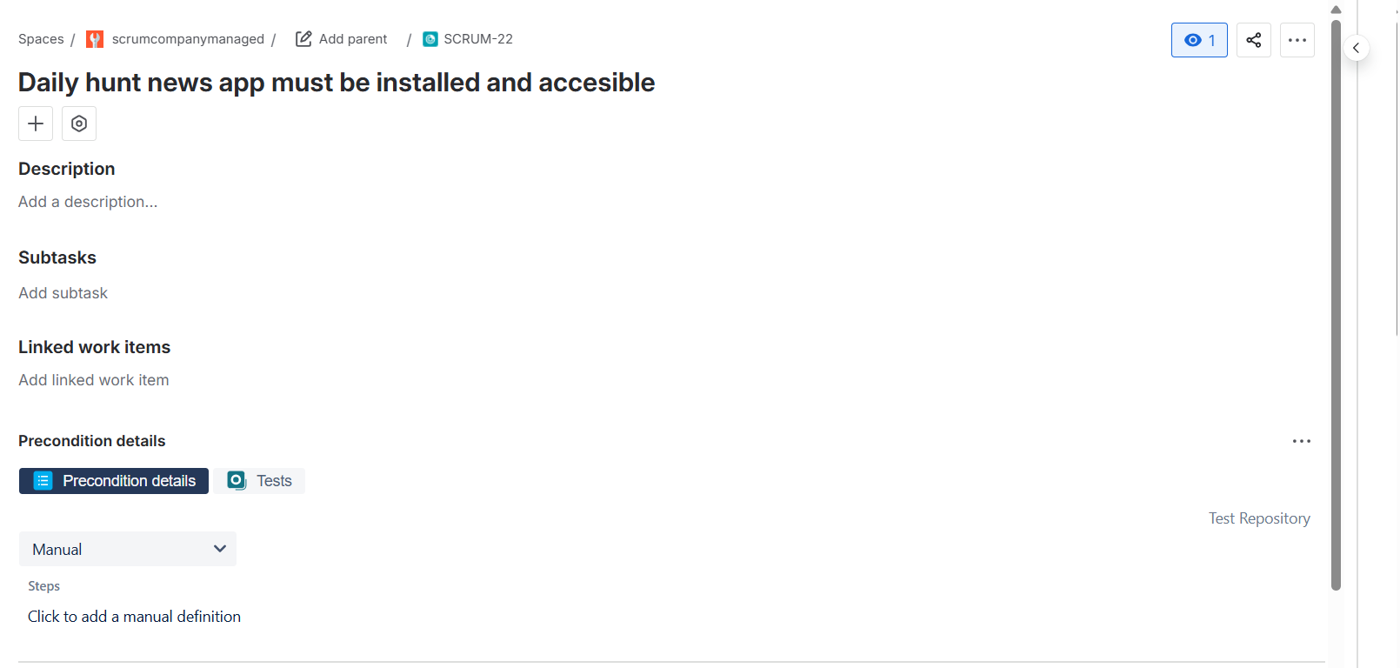
Linking existing precondition to the test
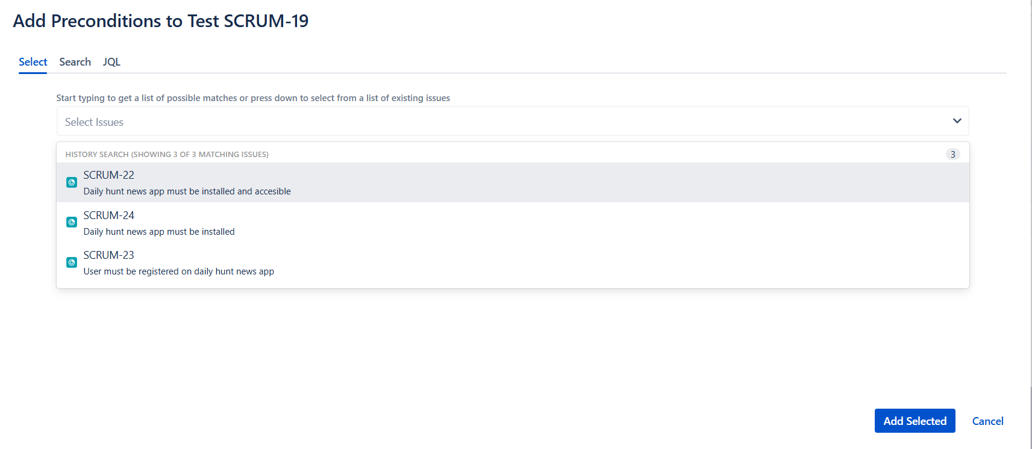
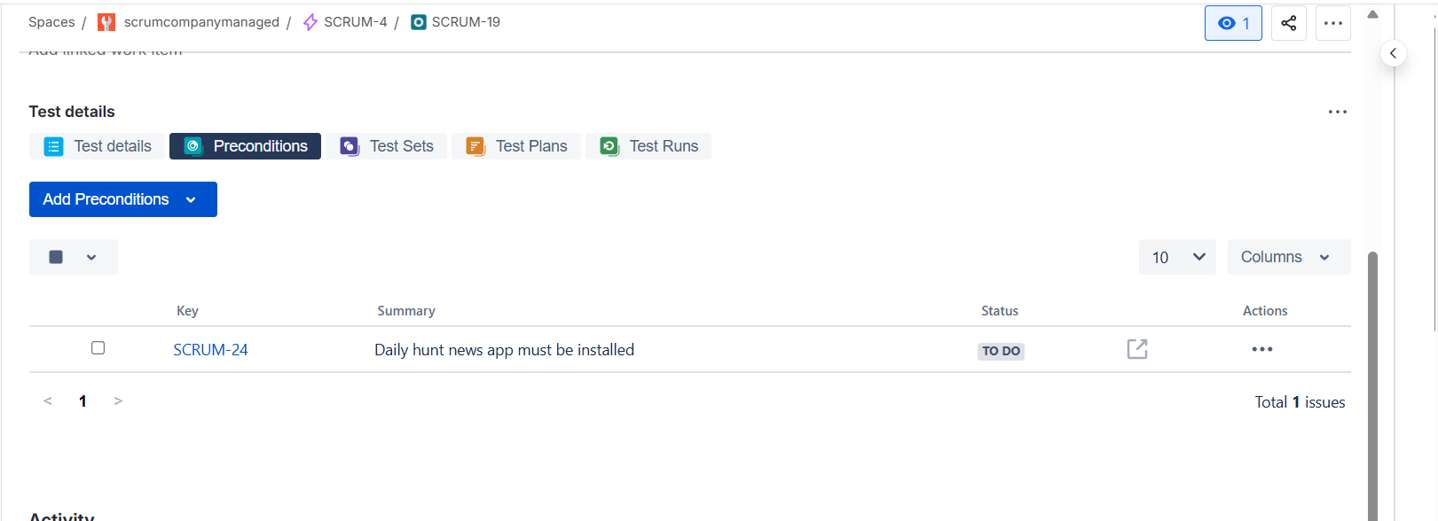

Creating a test execution

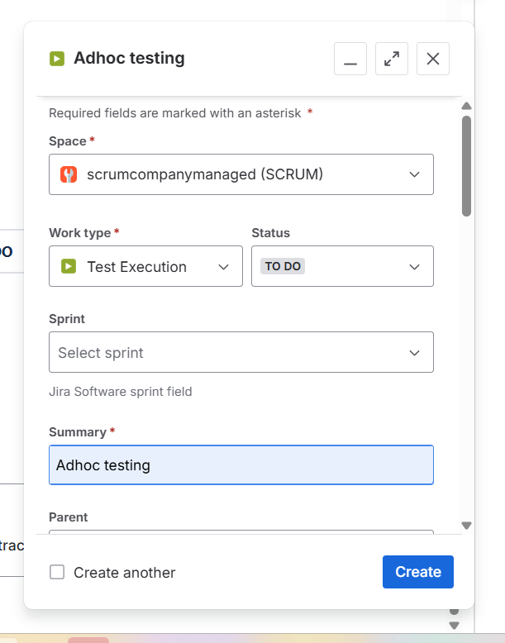
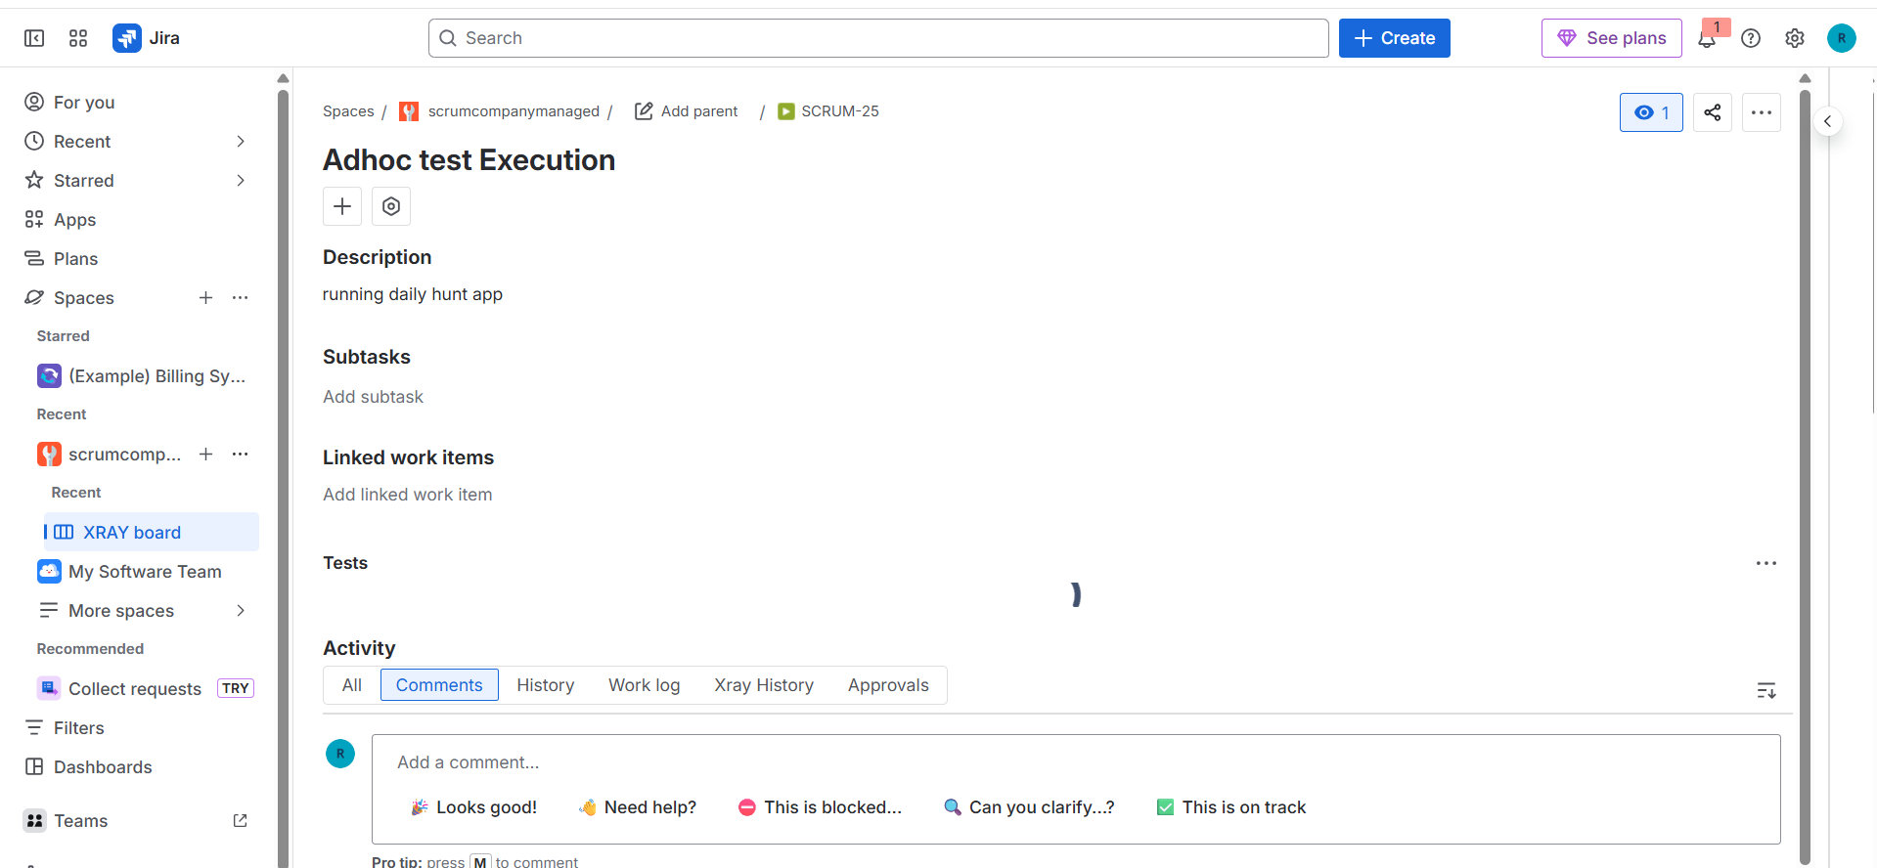

Adding existing tests for the test execution
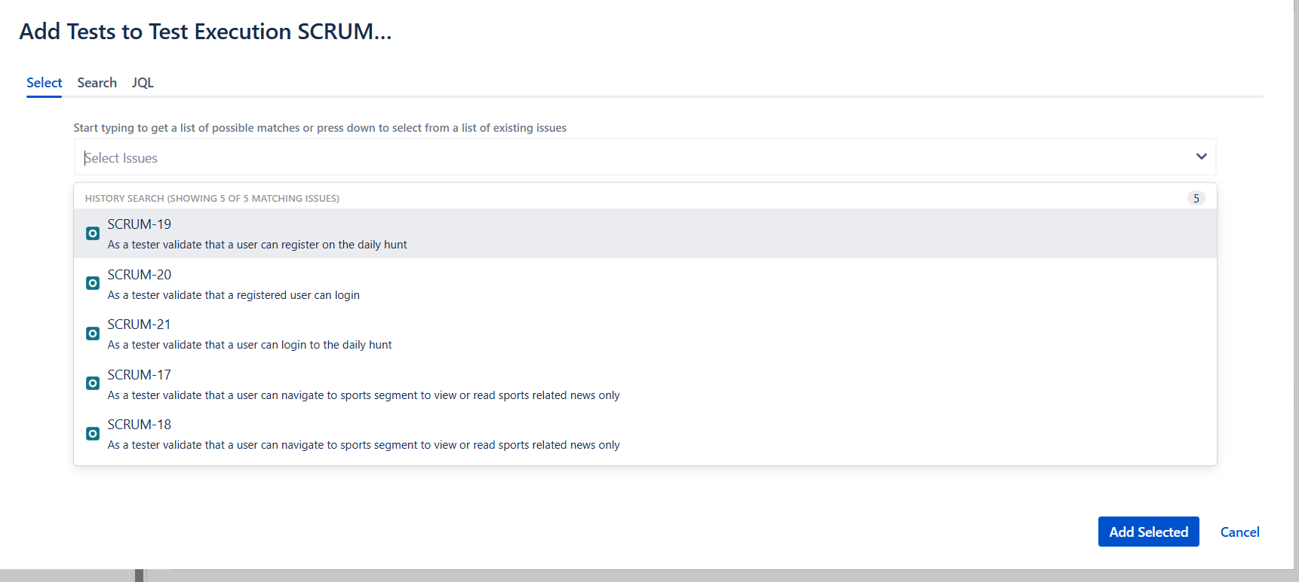

Which looks like this
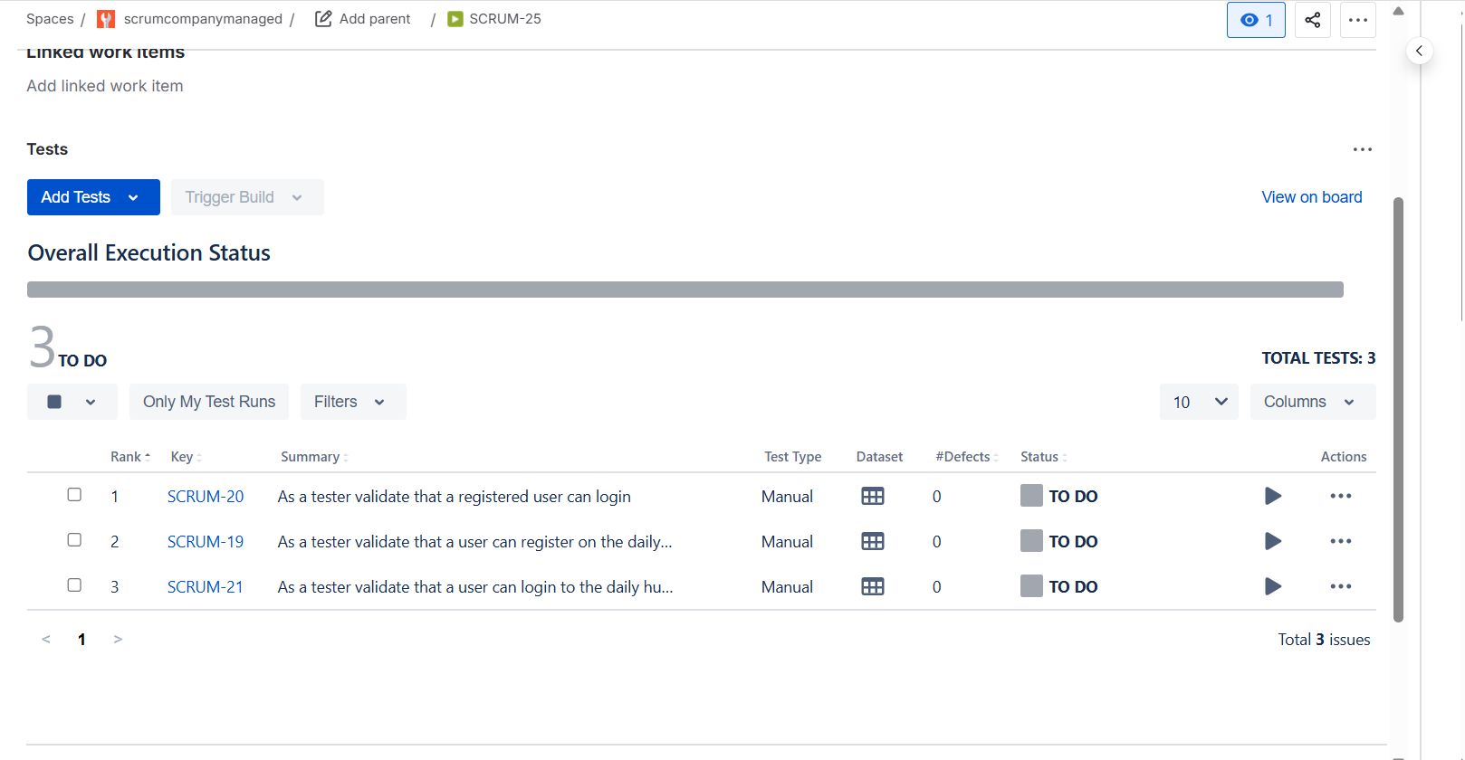
Running the tests
It redirects to the testing board
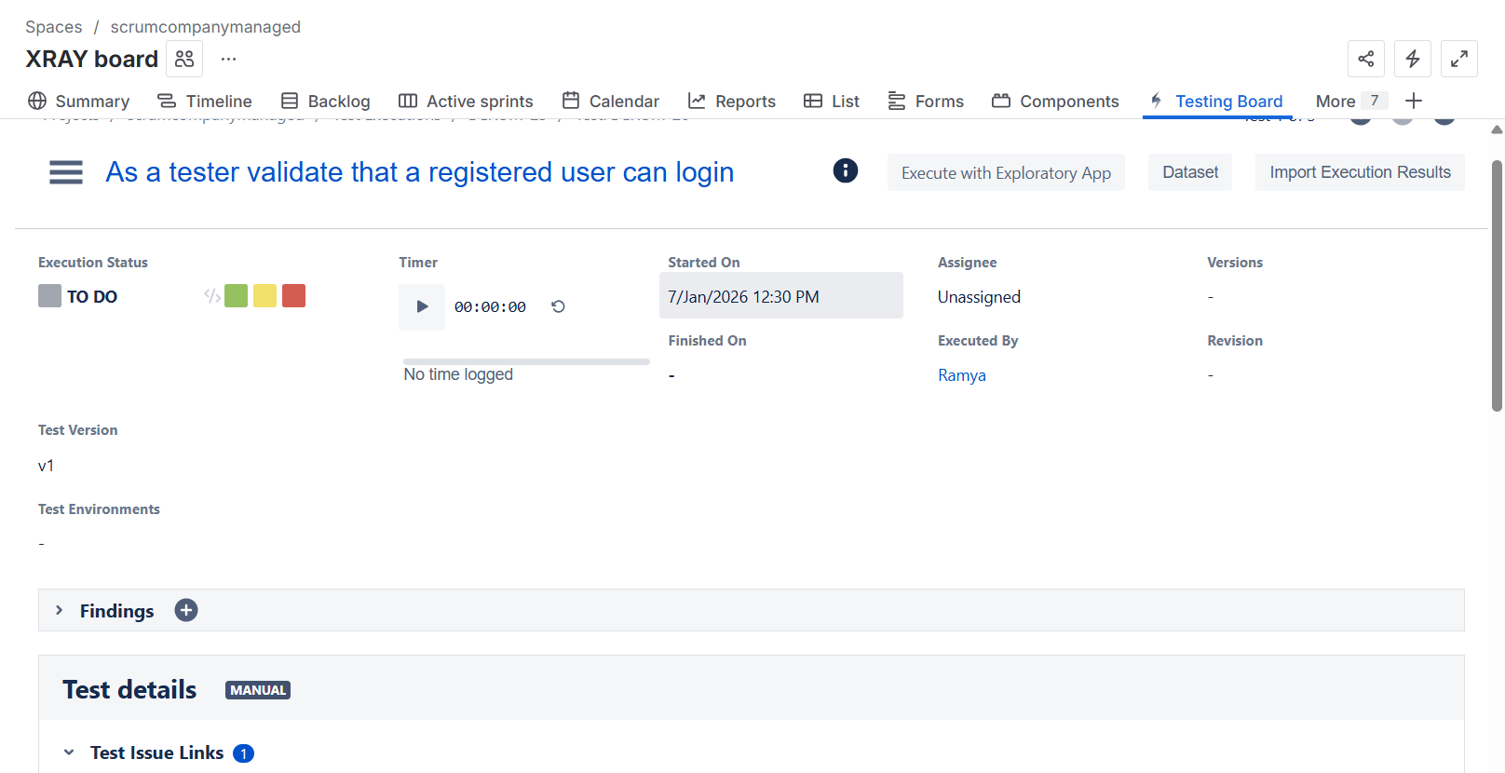
We can also add defects here
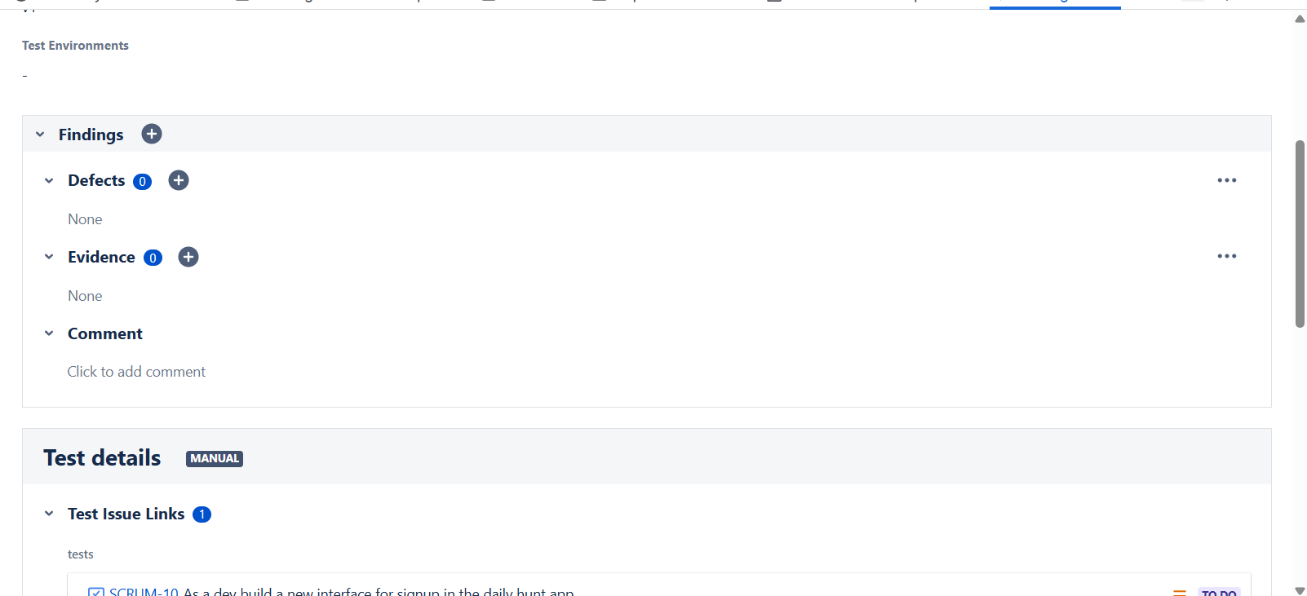
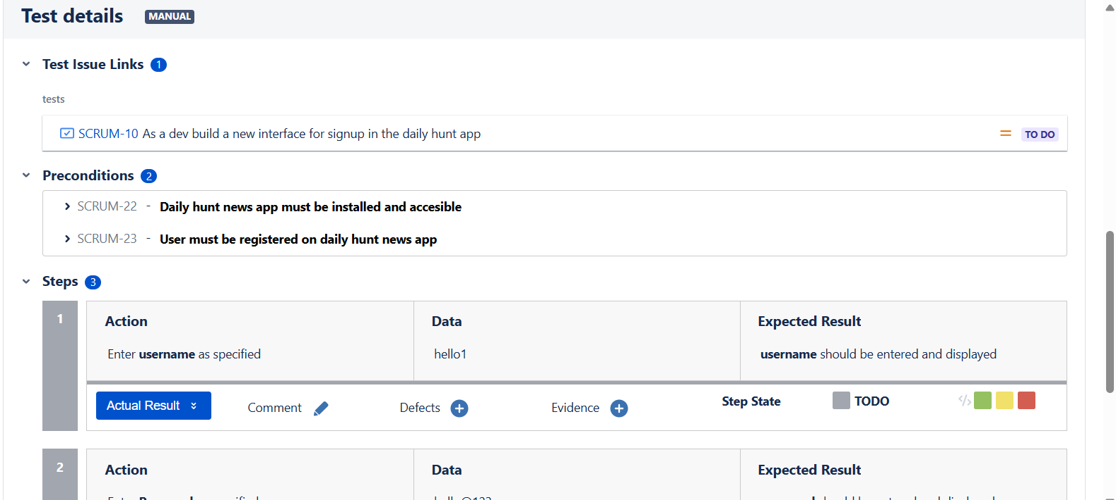
Add the actual result and also add the progress of that step
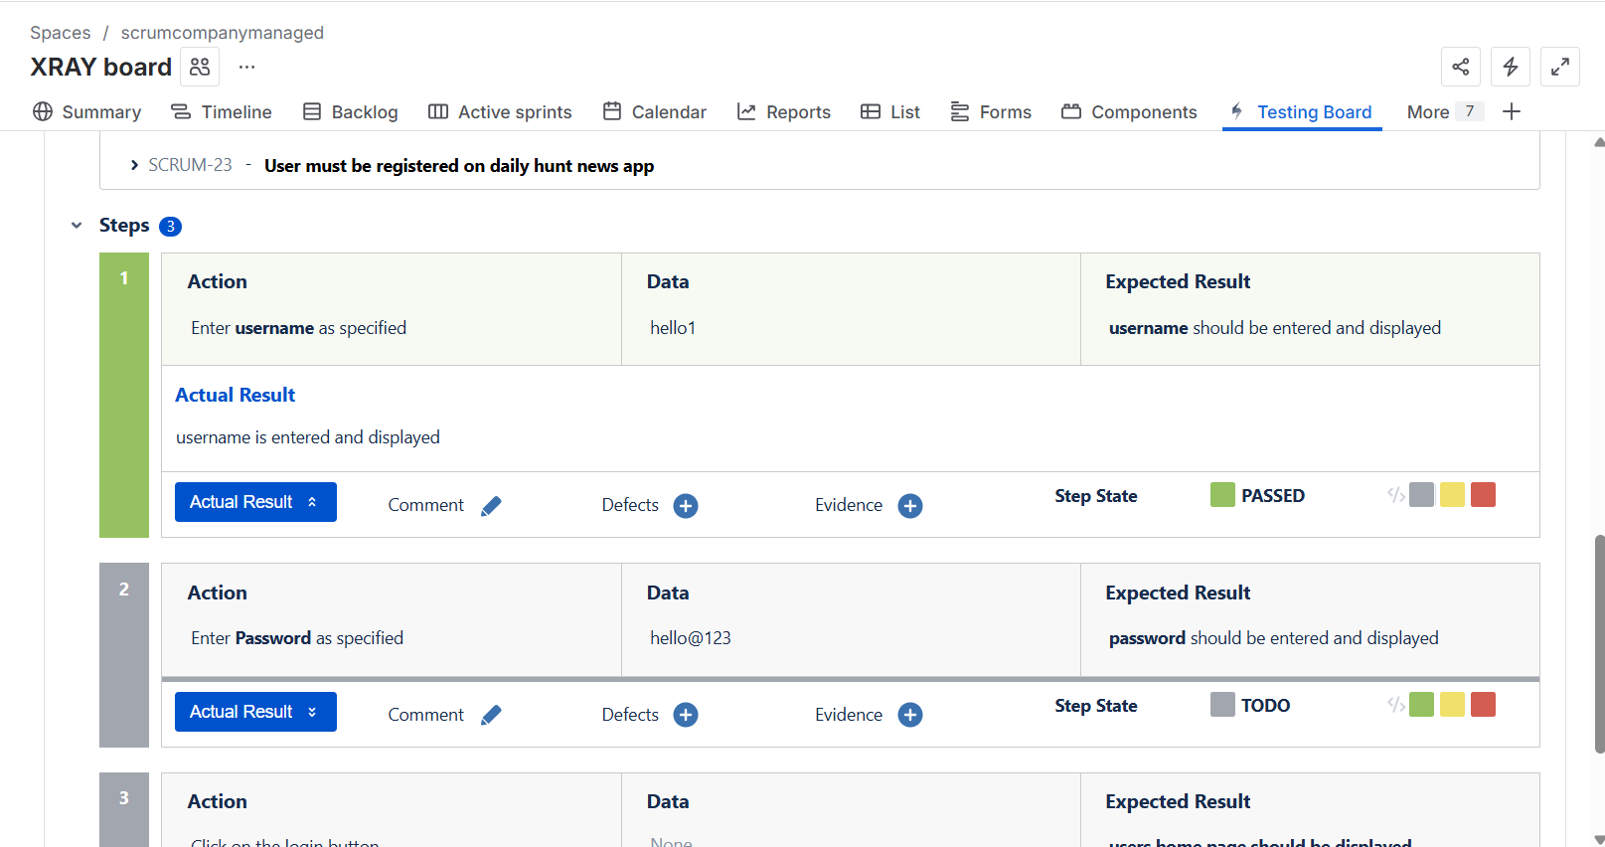
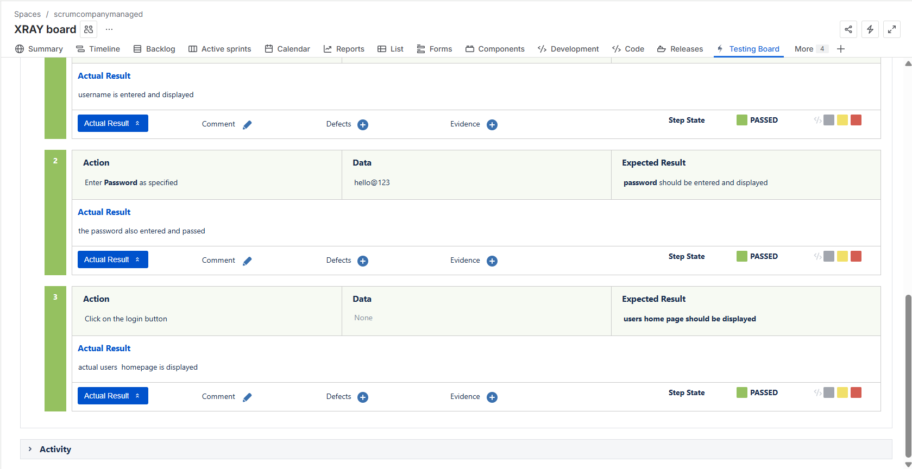
Defect which looks like
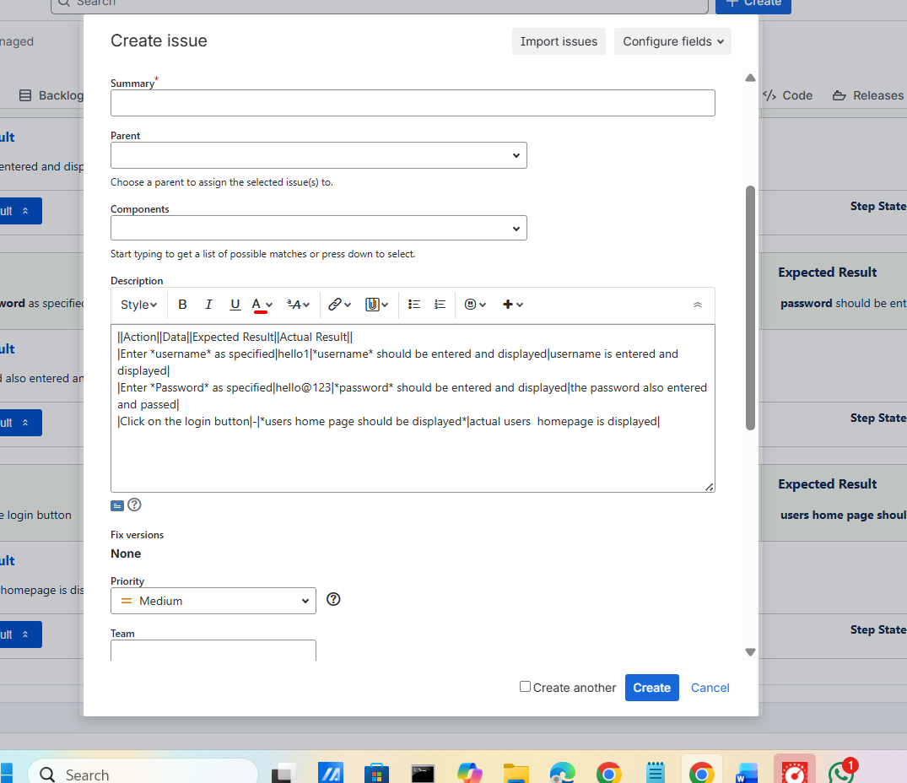
After completing all the tests in the test execution it looks like this
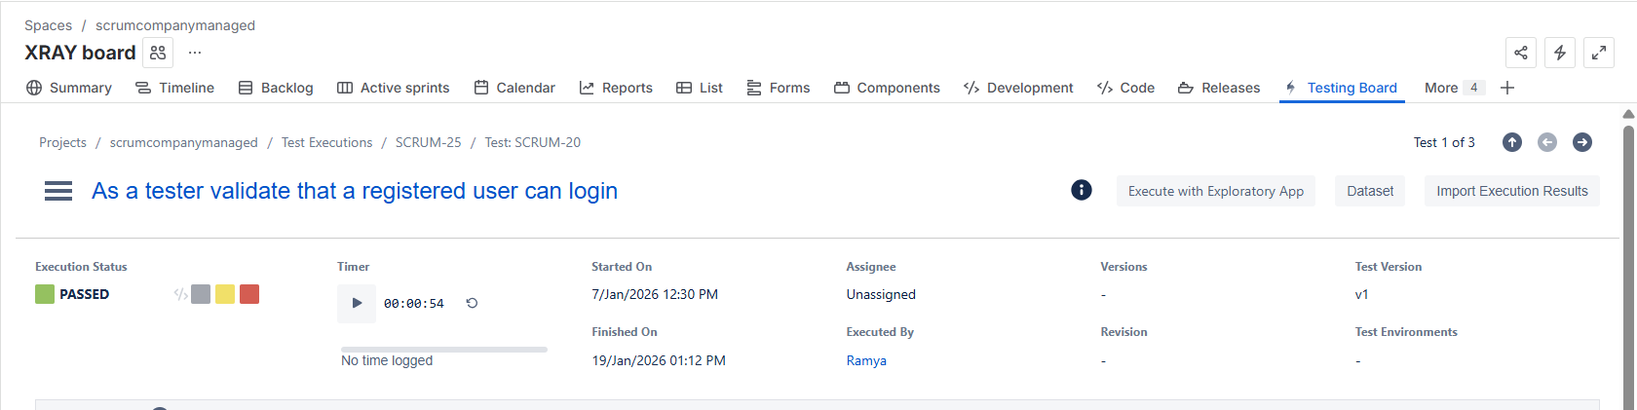
Overall status of the test execution
